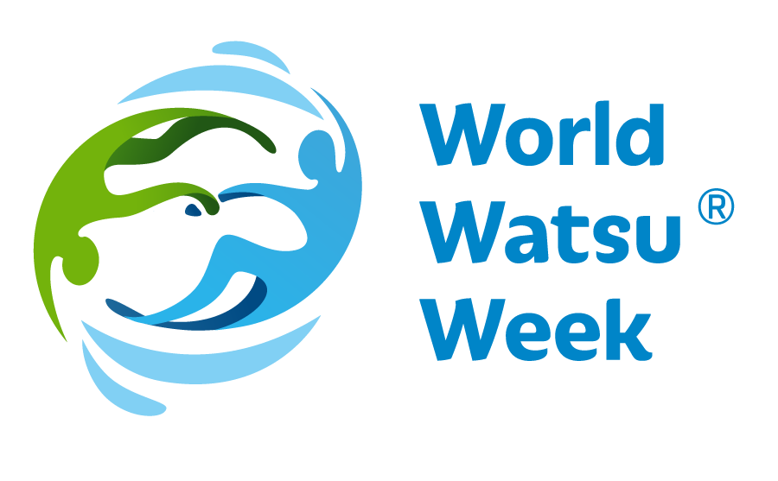
Press release dated 20.01.2020

.................................................................................................
World Watsu® Week 22- 28 March 2020 - 2nd year

World Watsu®Week 2019 saw a monumental wave of cooperation all over the world, promoting the exceptional technique of water therapy Watsu® (WAtersiaTSU). The Day of Water, i.e. 22.03.2019, opened the first year of raising awareness of this special technique among professional and nonprofessional public, free of charge across the whole world. The week was given the name World Watsu® Week and comes back a year later, with even greater power, to introduce the water therapy Watsu®to all who are interested. Since the 1980s, when Watsu® was developed by Harold Dull, has helped many people improve their physical and mental life thanks to its holistic effects. Also this year, World Watsu® Week, will host a great number of practical demonstrations, presentations, workshops and side events all over the world, when all participants will be able to try Watsu® themselves. Participants will be welcome to try and practise the therapy and discuss any points of interest. The year 2020 will focus on the use of Watsu® and other water therapies for the handicapped. This theme is not compulsory on the organizers, but, depending on the conditions and experience, organizers may provide information on this specialty, since Watsu® has great application in this area.
Please check informations and links to the programme in the individual countries on www.worldwatsuweek.com under the respective flag.

Under the auspices of the World Aquatic Bodywork Association WABA (www.watsu.com), the 2nd year of World Watsu® Week will be held on the World Water Day, 22.03.2020. Again, this week will bring plentiful events open to all interested participants, who will learn what Watsu®is and why similar holistic therapies have today gained so much importance for everyone. All participants will get an opportunity to try this exceptional technique and participate in side events during the whole week. This year, most locations will focus on the use of Watsu® and other water therapies for the handicapped. We believe that many people will find this interesting and helpful.
Considering the last year success, and exemplary cooperation among therapists and students of Watsu® also this year the World Watsu® Week will be held in the week from 22.03. to 28.03.2020. Locally, in various parts of the world, the dates of this week may be rescheduled to a later period. The reason is that, for example, in some countries where outdoor swimming pools are used, the climate may not be suitable for practising Watsu, or there may be other reasons. The second term for these countries is from 18.5. to 24.5.2020.
Although the World Watsu® Week may run in two waves, we all officially report on the common date of the World Watsu® Week from 22.03. to 28.03.2020, since only this approach will ensure that the event will have a media coverage and a strong organic impact, and interconnect all Watsu® water therapists across the whole world, propagating this beautiful therapy as a result.

WATSU® (Water Shiatsu) was created by Harold Dull in 1980. This technique was gradually developed and supplemented with aspects of massage, stretching and relaxation, and it soon entered the professional world. During this therapy, clients experience relaxation, massage, stretching and dance. The individual elements are selected individually according the client’s physical and mental needs.
WATSU® was first taught at Harbin Hot Springs, North California in the early 1980s. Harold Dull held the position of the principal of Harbin Shiatsu School and also incorporated WABA (Worldwide Aquatic Body Work Association), a promoter of this technique around the world and supervisor over the quality of professional education.
WATSU® has soon found its way into European countries. The year 1990 saw Harold Dull teach this method in Switzerland for the first time. Since then, Watsu® has spread over the whole of Europe and the world alike.
According to Harold Dull, Watsu® is for everyone - adults, children, seniors. This rehabilitation technique helps for joint pain or backache and has a strong relaxation impact. The technique has effect on meridians and body pressure points. As people experience deep relaxation during Watsu®, the technique relieves posttraumatic stress disorders and classic stress conditions or stress from overwork.
It is easy to fall for Watsu®!

More information and links to the individual countries:www.worldwatsuweek.com

