Press release
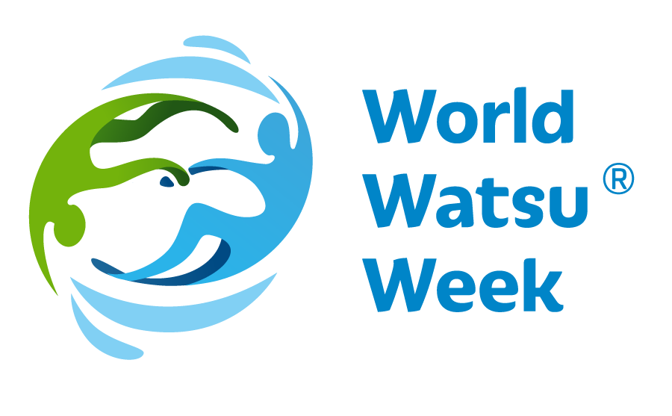
Worldwide Watsu® Week
22 - 28 March 2022
World Watsu®Week 2019 saw a monumental wave of cooperation all over the world, promoting the exceptional technique of water therapy Watsu® (WAtersiaTSU). The Day of Water, i.e. 22.03.2019, opened the first year of raising awareness of this special technique among professional and nonprofessional public, free of charge across the whole world. The week was given the name World Watsu® Week and this year, with even greater power, to introduce the water therapy Watsu® to all who are interested. Since the 1980s, when Watsu® was developed by Harold Dull, has helped many people improve their physical and mental life thanks to its holistic effects. Also this year, World Watsu® Week, will host a great number of practical demonstrations, presentations, workshops and side events all over the world, when all participants will be able to try Watsu® themselves. Participants will be welcome to try and practise the therapy and discuss any points of interest. The years 2020 and 2021 were significantly affected by the situation around Covid-19, most of the events were unfortunately canceled. But we believe that we will finally be able to continue the tradition this year and build on the enthusiasm of 2019.

On the occasion of the World Water Day, i.e. 22 March, the Worldwide Aquatic Bodywork Association WABA decided to host the World Watsu® Week. This event is open to all who might be interested in this therapy. Visitors will be introduced to the concept of Watsu® and will be explained the importance of Watsu® in the today’s world. Visitors will be welcome to try this unique technique and attend the side programmes. The events and the sessions are going to be for free. Throughout the long history of Watsu®, the year 2019 was mark the first time when this event was held in a large number of countries and cities at the same. The next two years, affected by the coronavirus pandemic, were limited in some countries. In 2022, Watsu® begins to wake up again and, if possible in each country and place, we will try to offer the maximum possible experience with Watsu®. To date, Watsu® has been brought to 75 countries around the world. There are 67 Training Institutes and WABA has registered around 5,000 students. In this number, Watsu® is already sailing to many places.

WATSU® (Water Shiatsu) was created by Harold Dull in 1980. This technique was gradually developed and supplemented with aspects of massage, stretching and relaxation, and it soon entered the professional world. During this therapy, clients experience relaxation, massage, stretching and dance. The individual elements are selected individually according the client’s physical and mental needs.
WATSU® was first taught at Harbin Hot Springs, North California in the early 1980s. Harold Dull held the position of the principal of Harbin Shiatsu School and also incorporated WABA (Worldwide Aquatic Body Work Association), a promoter of this technique around the world and supervisor over the quality of professional education.
WATSU® has soon found its way into European countries. The year 1990 saw Harold Dull teach this method in Switzerland for the first time. Since then, Watsu® has spread over the whole of Europe and the world alike.
According to Harold Dull, Watsu® is for everyone - adults, children, seniors. This rehabilitation technique helps for joint pain or backache and has a strong relaxation impact. The technique has effect on meridians and body pressure points. As people experience deep relaxation during Watsu®, the technique relieves posttraumatic stress disorders and classic stress conditions or stress from overwork.
It is easy to fall for Watsu®!

More information and links to the individual countries:www.worldwatsuweek.com

